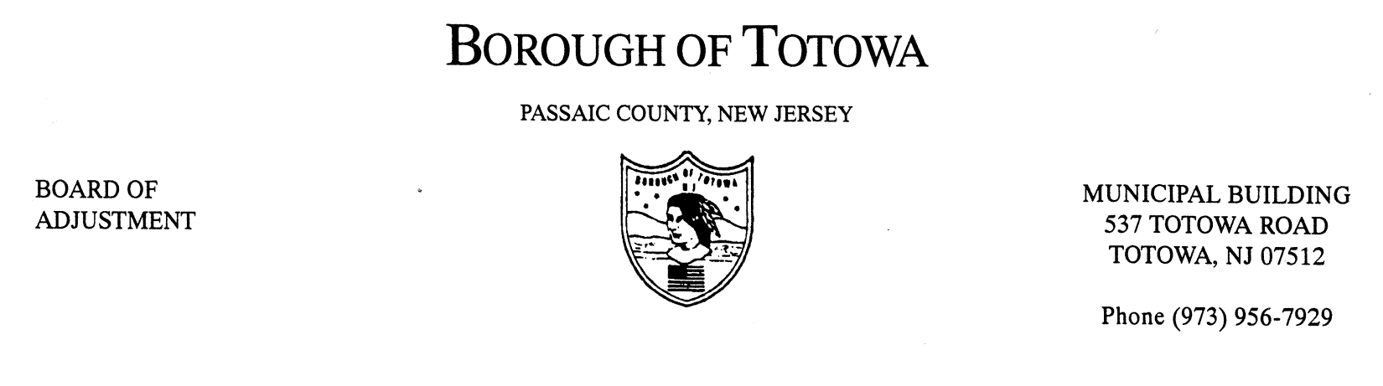
BOROUGH OF TOTOWA
BOARD OF ADJUSTMENT MINUTES
NOVEMBER 14, 2012

The November 14, 2012 regular meeting of the Borough of Totowa Board of Adjustment was held at the Municipal Building. Chairman Fierro called the meeting to order at 8:00 p.m.; followed by the Flag Salute.

Roll Call:
Present: Chairman Fierro, Vice Chairman Krautheim, Commissioners Niland, D’Ambrosio, Mancini, D’Aiuto, Alternate Cortese, Attorney Saracino, Engineer Murphy, Secretary Rattino.
Excused: Commissioner Patten, Alternate Korsakoff.

A motion to accept the minutes of the October 2012 meeting was made by Commissioner D’Ambrosio and seconded by Commissioner Mancini. On a roll call vote all Commissioners present voted in the affirmative.

1ST CASE: ADELINA SANTOS BOITEL (CARRY-OVER)
101 DEWEY AVENUE, BLOCK 115, LOT 33
Applicant requesting necessary variance(s) for construction of a bedroom within the attic space of a two-family home located in a single family zone – expansion of a non-conforming use. Represented by Franklin Soto, Esq. John Bleeker was sworn, Architect/Planner. Ms. Santos lives on the first floor and there is a tenant on the second floor. They propose to expand the third floor attic for an additional bedroom and a bathroom. There will be no outside additions. There will be no work to the roof line. There will be one access to existing unit and no access from outside to the third floor. The plans were revised and shown to the Board and marked A-1. The parking situation will stay the same. Engineer Murphy explained an additional non-conformity which is the basement having a wet bar and bathroom with a separate entrance which is not permitted. Also the third floor bathroom is not permitted.

Charmaine Ayala was sworn, the tenant on the second floor. She has lived at the residence for eight years with her husband and four children. The owner wants to expand in order for her to stay. The attorney interpreted for Adelina Santos, who was sworn. She explained the need for the apartment expansion.

Objectors to be Heard –
Joyce Klein of 76 Dewey Avenue questioned the fire escape for the third floor. She stated that she was told there is access from the front door to the third floor.

The architect plans to block this access off if the plan is approved. The building department will address the fire escape. Detectors will also be provided – all safety issues will be addressed. There are concerns with people living on the third floor. The plans indicate the closure of access. There was no more public to be heard.

A motion to deny the necessary variance(s) was made by Vice Chairman Krautheim and seconded by Commissioner D’Ambrosio. Vote to deny: 6-1. (Tape #1, #1 - #2679). Vote to approve: Commissioner Mancini.

THE FOLLOWING RESOLUTION(S) WAS MEMORIALIZED:
None.

A motion to adjourn the meeting was made by Commissioner Niland and seconded by Commissioner D’Ambrosio. The meeting ended at 8:50 p.m.

Respectfully submitted,
Karen Rattino, Secretary

