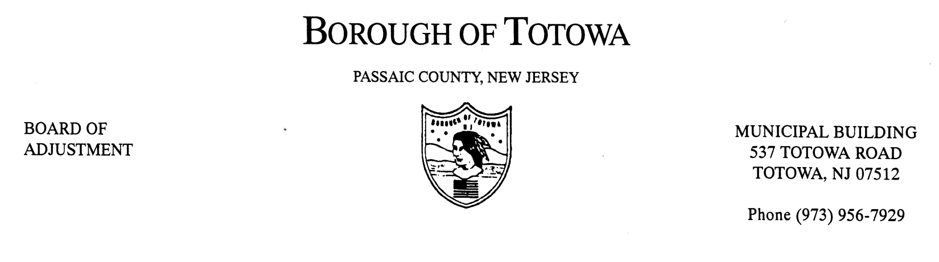
BOROUGH OF TOTOWA
BOARD OF ADJUSTMENT MINUTES
OCTOBER 10, 2012

The October 10, 2012 regular meeting of the Borough of Totowa Board of Adjustment was held at the Municipal Building. Chairman Fierro called the meeting to order at 8:00 p.m.; followed by the Flag Salute.

Roll Call:
Present: Chairman Fierro, Commissioners Patten, D’Ambrosio, Mancini, D’Aiuto, Secretary Rattino.
Excused: Vice Chairman Krautheim, Commissioner Niland, Alternate Korsakoff, Alternate Cortese, Attorney Saracino, Engineer Murphy.

A motion to accept the minutes of the September 2012 meeting was made by Commissioner Patten and seconded by Commissioner D’Ambrosio. On a roll call vote all Commissioners present voted in the affirmative.

1ST CASE: FRANKLIN G. SOTO (CARRY-OVER)
101 DEWEY AVENUE, BLOCK 115, LOT 33
Applicant requesting necessary variance(s) for construction of a bedroom within the attic space of a two-family home located in a single family zone – expansion of a non-conforming use. The public was notified and this case will be postponed to the November 14, 2012 meeting.

THE FOLLOWING RESOLUTION(S) WAS MEMORIALIZED:

1ST CASE: JHL REALTY D/B/A THE BARNYARD AND CARRIAGE HOUSE
754 TOTOWA ROAD, BLOCK 9, LOTS 44 AND 45
variance(s) granted for a non-conforming use removal and replacement with new non-conforming use – parking, outside storage and any others that may be required.

2ND CASE: ALMAFI CORP.
19 DUFFUS AVENUE, BLOCK 130, LOT 4
Variance(s) granted for accessory structure located within - required side yard setback and any others that may be required.

3RD CASE: ABIL REALTY
195 ROUTE 46 WEST, BLOCK 174, LOT 12
Variance(s) granted for building height – alteration to façade of building.

A motion to adjourn the meeting was made by Commissioner Patten and seconded by Commissioner D’Ambrosio. The meeting ended at 8:10 p.m.

Respectfully submitted,
Karen Rattino, Secretary

