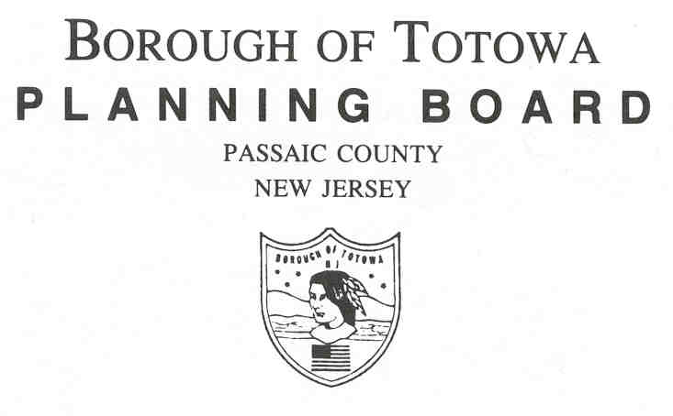
MUNICIPAL BUILDING
537 TOTOWA ROAD
TOTOWA, NJ 07512

Phone: 956-7929

agenda

FEBRUARY 26, 2026

Flag Salute

ITEM #1
Affordable Housing Law - P.L. 2024, c. 2
Borough of Totowa Compliance with 4th Round Rules

MINUTES:
Planning Board Minutes January 22, 2025

RESOLUTIONS:
Kessler Rehabilitation Center Block 100- Lot 1.01
Makeup by Sabrina Lux Block 174- Lot 14
Spa De La Mar Block 106- Lot 1.03

Patricia Paulson
Planning Board Clerk

