Borough of Totowa
PASSAIC COUNTY, NEW JERSEY
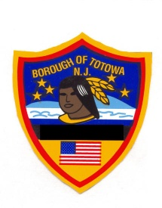
BOARD OF RECREATION
490 Totowa Road
Totowa, NJ 07512
973-956-1781

MARK MONTEYNE
Director

Totowa Day 125th Anniversary Celebration
515 Union Boulevard, Totowa, NJ

Saturday June10th at 3pm
(Rain Date: Sunday June 11th)
VENDOR APPLICATION
Business Name: ______________________________________________________________
Address: ____________________________________________________________________
City: _____________________________________ State: _____________ Zip: ___________
Owner Name: ________________________________________________________________
Owner’s Address: _____________________________________________________________
Telephone Number: ______________________ Fax Number: _________________________
Email Address: _______________________________________________________________
Items to be sold: [ ] Food* [ ] Clothing [ ] Other ______________________________
Signature: ___________________________________________ Date: __________________
EVENT INFORMATION

- Applications must be received by May 26, 2023.
- Must provide a Certificate of Insurance naming “Borough of Totowa” as an additional insured
indicating this specific event, with a minimum $1,000,000 per occurrence limit.
- Vendors should be set-up by noon on the day of the event.
- Food Trucks: Please supply your truck dimensions: ___________________________
- (*) Food vendors must also contact the Board of Health Department at (973) 956-1000, ext.
1008 for a Temporary Retail Food Establishment License for an additional $50 fee.

VENDOR FEE - $250

Vendor Fees will be collected after the application process. Please make check payable to: Borough of Totowa Board of Recreation and mail to:

Joseph Wassel, Municipal Clerk
Borough of Totowa
537 Totowa Road
Amt Rec’d: | Date: | By: | Check No:
Totowa, New Jersey 07512

